HOLE IN ONE RATING

Premiums Based on 150 Golfers!
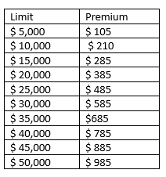
For prizes over $50,000 contact Sarah Ellis for pricing.
Application forms can be found on our website at: http://angusmillerltd.com/our-products/hole-in-one/. They can be completed electronically and submitted to Sarah Ellis by clicking the application button in the top right corner.
Hole in One Insurance is one of the many Specialty Lines products that Angus-Miller can offer at competitive rates! We also offer coverage for:
- Other types of Prize Indemnity
- Equipment Breakdown
- Surety
- Professional Errors and Omissions
- Commercial General Liability
- Logging Equipment
- Long Haul
- And much more!

